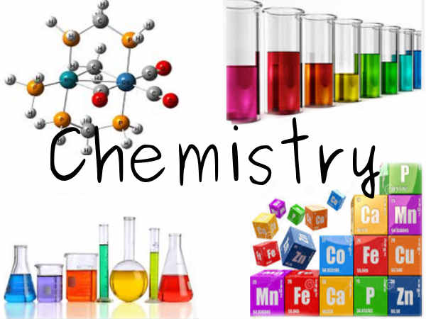
Science 10: Unit A: Chemistry
Lesson 1: Properties and Classification of
Matter/History of Chemistry
Physical Properties
- Describe the physical appearance and composition of a substance
Physical Property | Description
Boiling/ Condensing Point
Melting/Freezing Point
Malleability
Ductility
Colour
State
Solubility
Crystal Formation
Conductivity
Magnetism

Chemical Properties:
- Describe the reactivity of a substance
Chemical Property | Description
Ability to burn
Flash Point
Behaviour in Air
Reaction with water
Reaction with acids
Reaction to heat
Reaction to red and blue litmus

Pure Substance – all particles are identical
- Made up of an element or a compound

Mixture – combination of pure substances
- Heterogeneous (Mechanical) – different substances are visible
- Suspension- particles are visible and in different states
- Homogeneous (Solution) – separate components are not visible
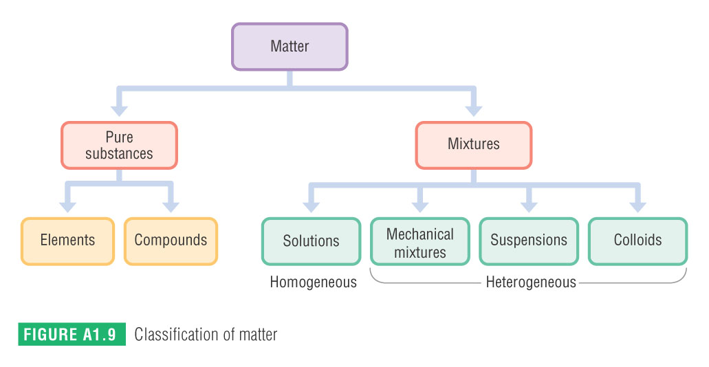
To observe a physical property you can change the state of the substance.

To observe a chemical property you must see how the substance reacts with a different substance(s).
A chemical reaction involves the process of creating a new substance with its own physical and chemical properties.
Recognizing chemical reactions
- Produces a new substance
- Change in temperature
- Phase change (bubbles, solid, cloudy)

Metallurgy – science of producing and using metals
- Gold, copper, silver, lead , iron before 3000BC
- Copper was used in weapons but broke easily when shaped
- Heat the copper before shaping; annealing
- Smelting – heat the substance to separate the metals in a compound
- Alloy - mixing metals
  - Bronze = copper and tin
  - Steel = iron and carbon

Aristotle
- Matter composed of combinations of fire, earth, water, and air

Democritus
- Matter made up of tiny particles that cannot be divided
- He called the particles atoms

Alchemy – combination of science and magic
- Scientists tried to change lead into gold
- Made many advances; scientific process, lab equipment, element discovery

Models of Atom

John Dalton (1766-1844)
- He thought the atoms were small spheres with varied size, mass, colour
- Dalton’s Model of the Atom
  - All matter is made of small indivisible particles called atoms
  - All atoms of an element are identical in size and mass
  - Atoms of different elements have different properties
  - Atoms of different elements combine in specific fixed ratios to form new substances

JJ Thompson (1856-1940)
- Discovered the electron
- Suggested the atom was positively charged sphere with negative particles imbedded in it
- Nagaoko proposed that the electrons travelled around the sphere like the rings of Saturn
Rutherford (1871-1937)
- Discovered the nucleus of the atom
- The atom is mostly empty space with a tiny positively charged core

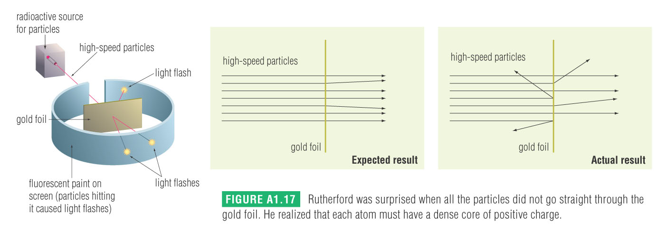

- Calculated the nucleus to be about 1/10000 the size of the atom, an ant on a football field

Neils Bohr (1885-1962)
- Proposed electron surrounded the nucleus at specific energy levels
- Electrons release light when they fall from an energy level
- Don’t fall into positively charged nucleus because they cannot go past the lowest level.
Quantum Model of the Atom
- Each electron is a cloud of negative charge
- The electron cloud surrounds the nucleus
- The nucleus contains protons and neutrons.
  - Protons have a positive charge
  - Neutrons have no charge

Homework;
p. 17; 3, 4, 6

Lesson 2: The Periodic Table and Atomic Structure

The Elements
Element – cannot be broken down to other substances
- 94 naturally occurring and 24 synthetic

Metal – good conductor of heat and electricity
- Malleable (sheets) or ductile (pulled into wire)
- Most silver or grey and shiny
- Most solids, expect mercury
- Some highly reactive with air and water
- Some are inert (unreactive), except with highly corrosive acids
- Examples;

Non- Metal - only 17
- Do not resemble metals but do resemble one another
- Variation in the colour, reactivity, state
- 11 are gases, 5 solids, and 1 liquid
- About half exist as interconnected atoms called molecules. Some are called diatomic
  - Oxygen, O_{2,} Neon is not

Metalloids – intermediate between metals and non-metals
- Silicon, boron, arsenic, germanium, antimony, tellurium, polonium, astatine

The Periodic Table
- Metals on the left and non-metal on the right
- In between is the metalloids
- Hydrogen is a non-metal, but is with the metals because it acts like a metal in reactions.

Atomic Number
- Number of protons in an element
- Increases on the periodic table
Mass Number
- Atoms that have different numbers of neutrons than protons are called isotopes
- Atomic molar mass is the average mass of the elements isotopes

Period- horizontal line (row)
- Numbered from 1 to 7

Group – vertical line (column)
- Numbered from 1 to 18 (sometimes with roman numerals)
Group 1 Alkali Metals
- Soft shiny and silver
- Very reactive with water

Group 2 Alkaline Earth metals
- Shiny and silver, not as soft as group 1

Group 18 Noble Gases
- Very unreactive

Group 17 Halogens
- Poisonous and react with alkali metals to form salts

³ Li
Lithium
6.94
__________
Li⁺
Lithium

¹⁷ Cl
Chlorine
35.45
__________
Cl⁻
Chloride

Homework. Worksheet 1.1 and 1.2 Periodic Table
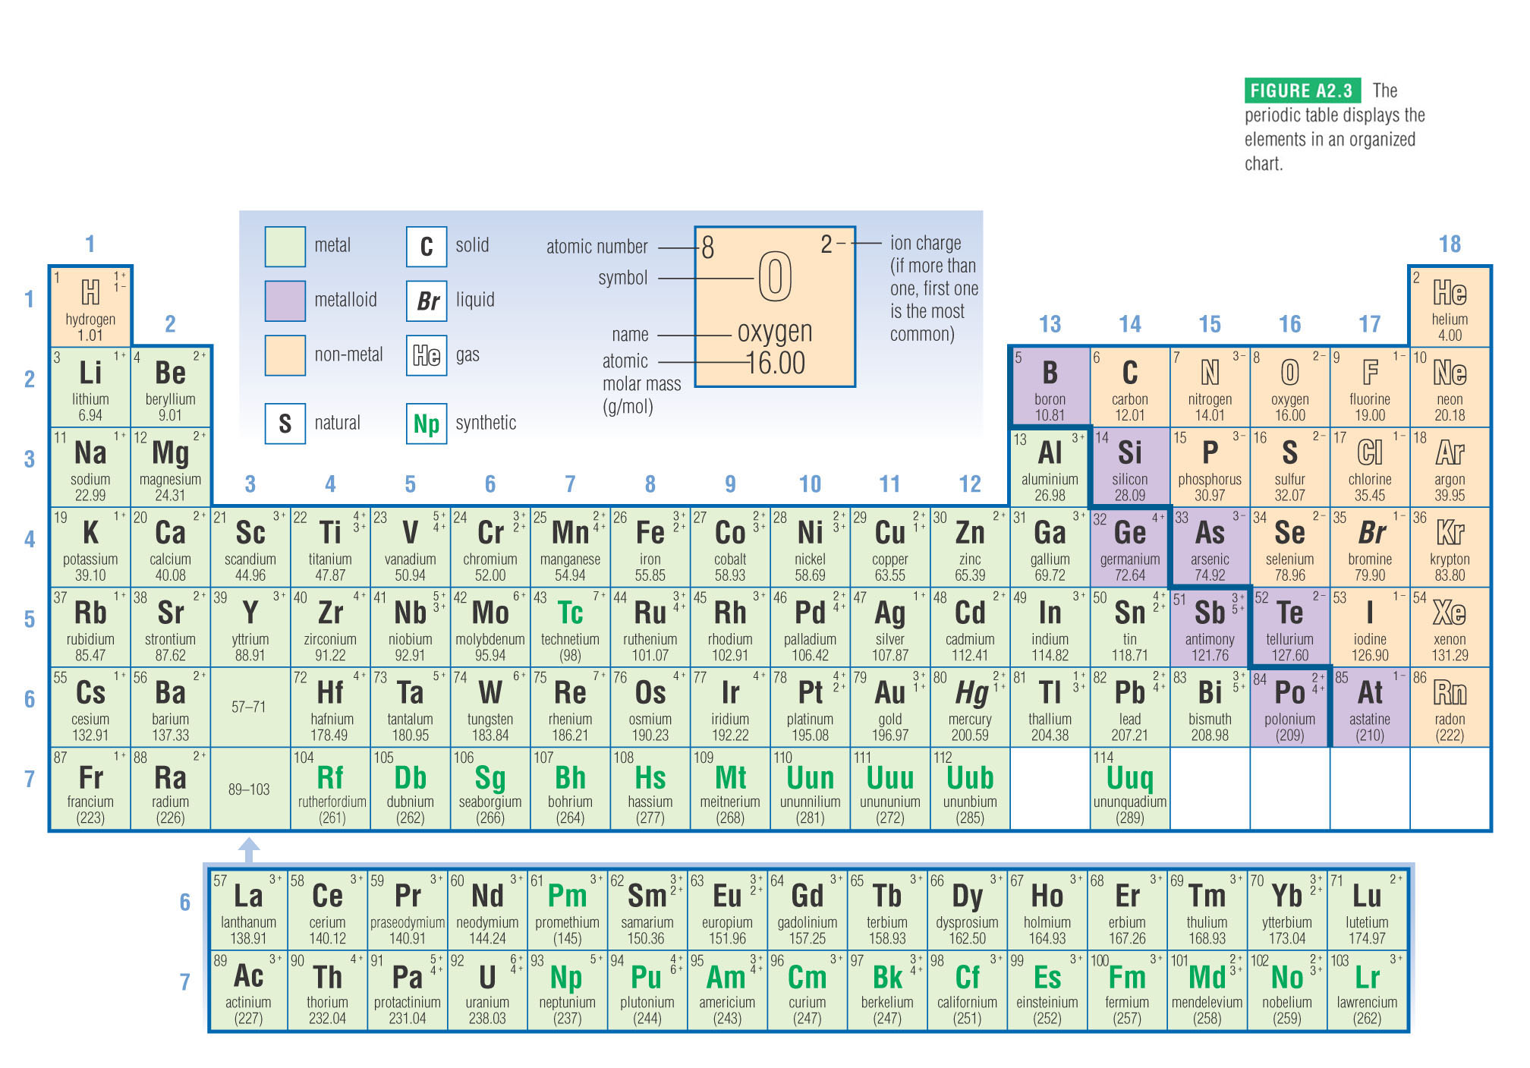
Lesson 3: Atomic Theory

- Smallest piece is called an atom.
- An atom contains protons (positive charge) , neutrons (no electrical charge), and electrons (negative charge)
- The nucleus contains protons and neutrons, which is about 99.9% of the mass
- The atomic number is the number of protons in the nucleus, Helium has __, Gold has ___; Magnesium has ___
- Electrons surround the nucleus. Each electron is in a specific energy level

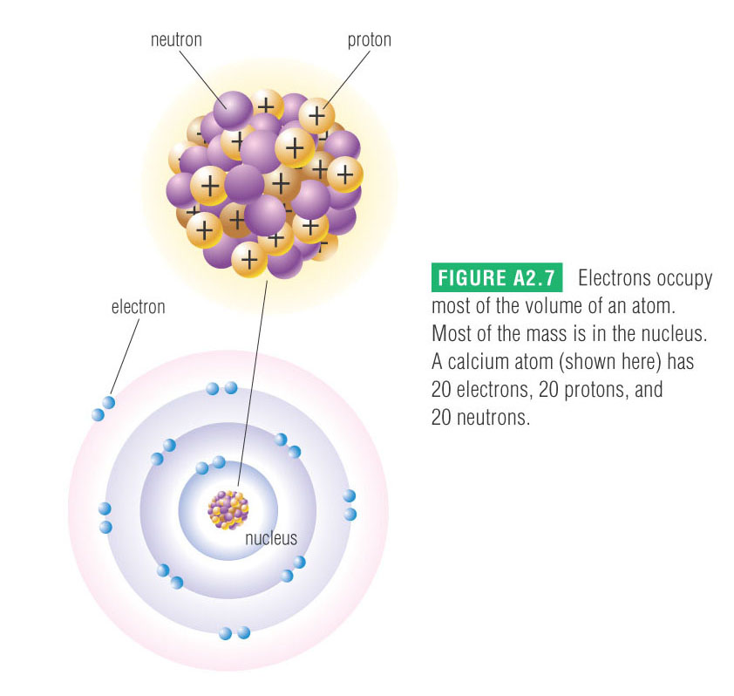
Energy Levels
- Region around the nucleus that either has an electron or is empty
- Like spheres being added around the nucleus
- First level can hold 2 electrons
- Second level has 8 electrons
- Third level has 8 electrons
- We will learn up to 20, after that the pattern gets complicated.
- An energy level can be empty, partly filled, or completely filled.
- Partly filled levels can overlap with another atom, this will make a molecule

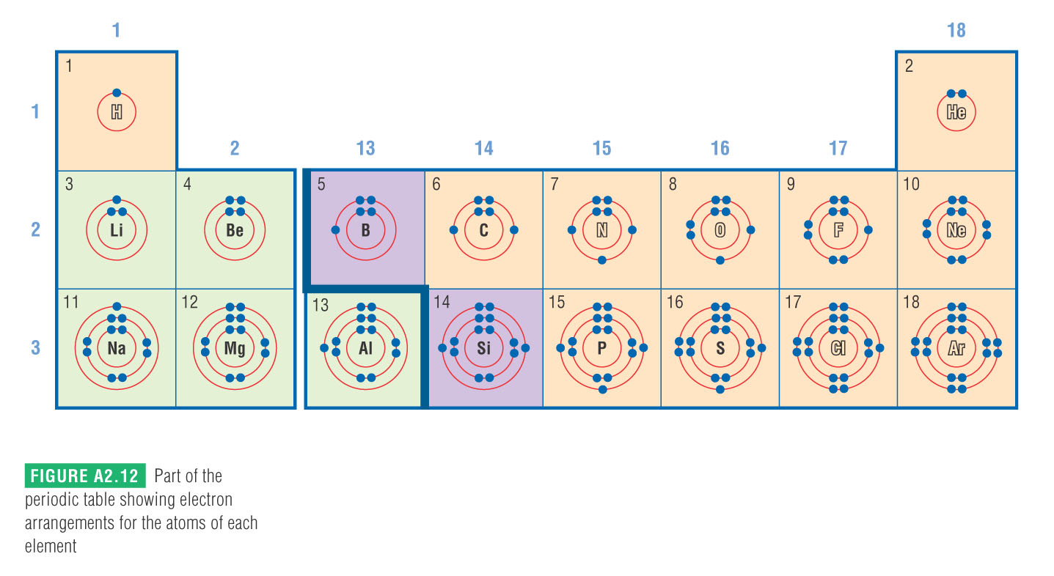

Formation of ions
- Gain or lose outer most electrons, ionization
- Ion = electrically charged atom (or group)
- Cation = positively charged ion, form when a metal loses electrons
Example: Magnesium atom
Anion – negatively charged ion, form when non-metal gains electrons
Example: Oxygen

Why do atoms gain or lose electrons?
- They want to have the same number of electrons as the nearest noble gas.
- More stable = less reactive

Homework; p. 39 1 -7

Lesson 4: Ionic Compounds
- Electrically neutral (no charge)
- A cation (+ charge) joins with an anion (- charge)
- A metal ion and a non-metal ion
- Total number of electrons released equals total number of electrons gained
- All ionic compounds are solids at room temperature
- Has to be in the lowest ratio

Steps for Writing Ionic Compounds:
1. Identify the ions and their charges.
2. Determine the total charges needed to balance.
3. Note the ratio of cations to anions.
4. Use subscripts to write the formula, if needed.

Examples
1. Write the correct name and chemical formula for the following.
a) silver and iodine | silver iodide |  | AgI_{(s)}
b) magnesium and oxygen
c) calcium and nitrogen
d) zinc and selenium
e) aluminium and fluorine
f) potassium and chlorine
g) silver and oxygen

2. Write the correct names for each of the following compounds.
a) MgCl₂
b) CsF
c) CdO
d) MgBr₂
e) K₂S
f) Li₃P

Homework: Worksheet

Lesson 5: Multi-charge Ionic Compounds

- Same as previous lesson.
- Some metals have more than 1 possible charge, the most common is written first
- Example: Fe (iron), Pb (lead), Cu (copper)

- Balance the charges so the compound equals 0.
- Decide which charge to use.

Examples
- PbCl₄

- PbCl₂

- SnO

Given the name, determine the formula

- Iron (II) chloride

- Chromium (II) sulfide

- Manganese (IV) fluoride

Homework: Worksheet
Lesson 6: Polyatomic Ions

- Complex ions, listed on the data booklet
- In a specific order so you can see what it is ( alcohol, acid)

- Fe(NO₃)₂

- NH₄NO₃

- Pb₃(PO₄)₂

Write the formula for the following compounds

- Copper(II) sulfate

- Ammonium sulfite

- Aluminum hydroxide

Homework: Worksheet

Lesson 7: Molecular Compounds
- 2 or more non-metals bonded together
- Can be different (CH₃OH) or the same (O₂)
- Independent units made up of fixed number of atoms bonded together.
- Can be solid, liquid or gas
- Atoms are joined together with covalent bonds, atoms share electrons.
- Electrons are not transferred from one atom to another
- Examples of covalent bonds are
  - Water H₂O
  - Ammonia NH₃
  - Sugar C₁₂H₂₂O₁₁

Monatomic | C _{(s)} Noble gases All metals
Diatomic | H_{2(g)} N_{2(g)} O_{2(g)} F_{2(g)}  Cl_{2(g)} Br_{2(l)} I_{2(s)}
Polyatomic | O_{3(g)}(ozone) P_{4(s)} S_{8(s)}

Naming Molecules without hydrogen
- Greek prefixes are used to indicate the amount of each element present in a compound

Number | 1 | 2 | 3 | 4 | 5 | 6 | 7 | 8 | 9 | 10
Prefix | mono | di | tri | tetra | penta | hexa | hepta | octa | nona | deca

- Format for naming
Prefix + first element followed by prefix +second element ending in ide
- If the first element is only one, the mono prefix is not used

Steps | N₂O_{(g)} | PBr_{3(g)}
- Name first element
- Name second element “ide”
- Add prefixes

Molecular Compounds that contain Hydrogen
IUPAC Name | Formula and State at 25⁰C
Water | H₂O_{(l)}
Hydrogen peroxide | H₂O_{2(l)}
Ammonia | NH_{3(g)}
Sucrose | C₁₂H₂₂O_{11(s)}
Methane | CH_{4(g)}
Propane | C₃H_{8(g)}
Methanol | CH₃OH_{(l)}
Ethanol | C₂H₅OH_{(l)}
Hydrogen Sulfide | H₂S_{(g)}

Homework: Molecular compounds
Lesson 8: Solubility Table
Using the table on p. 10 of your data booklet. Determine if the following are soluble (aq) or slightly soluble (s).
Solubility of Some Common Ionic Compounds in Water
Note: Group 1 = Li⁺, Na⁺, K⁺, Rb⁺, Cs⁺, Fr⁺
Group 2 = Be²⁺, Mg²⁺, Ca²⁺, Sr²⁺ Ba²⁺, Ra²⁺
“all” means “all compounds containing these ions”
“most” means “most compounds containing these ions”
“only with” means “only compounds containing” the ion or ions listed
Ion | Group 1  NH₄⁺  H₃O⁺ (H⁺) | ClO₃⁻  NO₃⁻  ClO₄⁻ | CH₃COO⁻ | Cl⁻  Br⁻  I⁻ | SO₄²⁻ | S²⁻ | OH⁻ | PO₄³⁻  SO₃²⁻  CO₃²⁻
Very Soluble | all | all | most | most | most | only with:  Group 1  Group 2  NH₄⁺ | only with:  Group 1  NH₄⁺  Sr²⁺  Ba²⁺  Tl⁺ | only with:  Group 1  NH₄⁺
Slightly  Soluble | none | none | only  with:  Ag⁺  Hg⁺ | only with:  Ag⁺  Pb²⁺  Hg⁺  Cu⁺  Tl⁺ | only with:  Ca²⁺  Sr²⁺  Ba²⁺  Ra²⁺  Pb²⁺  Ag⁺ | most | most | most

Formula | Solubility
NaCl
PbCl₂
PbCl₄
BaSO₄
Cr₂S₃
CsCH₃COO
K₂CO₃

Lesson 9: Chemical Change
Chemical reaction- when a substance(s) react to create new substance(s) accompanied by either energy flowing into the system or out of the system.
Reactants- products that react
Products- what the reaction makes

States in Chemical Formulas
- Solid - (s); Liquid –(l); Gas (g); Aqueous (aq)
- CO₂(g) at 25⁰C or CO₂(s) is dry ice
- Table salt; NaCl _{(s)} dissolved in water is NaCl _{(aq)}
- Elements;
  - All metals are solid except mercury,
  - Non metals; H_{2(g)} N_{2(g)} O_{2(g)} F_{2(g)} Cl_{2(g)} Br_{2(l)} I_{2(s),} sulfur, carbon and phosphorous are solids
- Compounds
  - Ionic are solids
  - If it is dissolves in water it is aqueous, if not it is a solid
  - Molecular are hard to predict, although the larger they are the more they tend to be liquids and solids.
CH₄- natural gas
C₆H₁₄ – liquid component of gas
C₁₈H₃₈- bees wax

Energy Changes
Exothermic- energy is released in the form of heat, light or electricity
Combustion – when oxygen reacts rapidly with a new substance and gives off energy.
Coal Combustion – used to make steam that drives turbines

Gasoline – in automobiles
2 C₆H_{14(l)} + 19 O_{2(g)}12 CO_{2(g)} + 14 H₂O_{(l)} + energy

Endothermic – absorb energy
Biochemical – happen at the organism’s internal temperature.
Photosynthesis- an endothermic reaction that captures the sun rays and turns the energy into sugar. The oxygen is expelled for us to breathe.
Energy + 6 CO_{2(g)} + 6 H₂O_{(l)} C₆H₁₂O_{6(aq)} + 6 O_{2(g)}

Cellular Respiration – an exothermic reaction that releases energy for plants and animals to use in other tissues and organs,
C₆H₁₂O_{6(aq)} + 6 O_{2(g)} energy + 6 CO_{2(g)} + 6 H₂O_{(l)}

Characteristics of Chemical Reactions
- Produces new substances with own properties
- Involve energy flow (change in temperature)
- Change of state may be observed
- Mass is conserved

Conservation of Mass
- Total mass of the system is conserved (reactants and products)
- Example; burning magnesium. 23.0 g of magnesium metal is burned in pure oxygen. The product is weighed and 39.0g of magnesium oxide is collected. Where did the extra 16.0 g come from? That is the pure oxygen that reacted with the magnesium metal.
Lesson 10: Chemical Equations
- What reactants make what products
- Chemical change is accompanied by the one of the following events; production of gas (bubbling), release of heat, change in colour, slightly soluble (cloudy)
Word Equations:
Solid magnesium metal reacts with aqueous hydrochloric acid to produce aqueous magnesium chloride and hydrogen gas.
magnesium + hydrochloric acid magnesium chloride + hydrogen gas
An iron nail is placed in a solution of copper(II) chloride. Iron (II) chloride and copper is produced.

Skeletal Equations:
Identifies the substances that are in an equation but not the correct proportions of the reactants and products.

H_{2(g)} + O_{2(g)} H₂O_{(l)}

Balanced Equations:
Correct proportions of reactants and products because of the law of the conservation of mass. An equation is balanced if the same number of each type of atom are on both sides of the equation.
___H_{2(g)} + ____O_{2(g)} ____H₂O_{(l)}
Example: Balance the following equations
- oxygen + methane carbon dioxide + water

- nitrogen + hydrogen ammonia

- solid sodium metal reacts with chlorine gas to produce solid sodium chloride

- mercury(II) sulfide is decomposed into liquid mercury and solid sulfur

- methane gas reacts with oxygen gas to produce carbon dioxide gas and water vapour
- __ H₂SO_{4(aq)} + __ Al(OH)_{3(s)} → __ Al₂(SO₄) _{3(aq)} + __ H₂O_{(l)}

- __ Co(NO₃)_{3(aq)} + __ Zn_{(s)} → __ Zn(NO₃)_{2(aq)} + __Co_{(s)}

Homework: Balancing Equations
Lesson 11: Formation Reactions
- 2 or more elements combine to make a new substance
- Also known as synthesis or composition reaction
- Element + element →compound

Example
- Sulfur burns in air and makes sulfur dioxide

- Hydrogen and nitrogen form to make ammonia (NH₃)

- Magnesium and carbon and oxygen form to make magnesium carbonate

- Sodium plus silicon plus oxygen to make sodium silicate

- Magnesium plus fluorine to make

- Silver plus oxygen to make
Lesson 12: Decomposition Reaction
- A compound is broken down to its elements
- A difficult process that can require special equipment
- Compound → element + element

Examples:
- Solid aluminium chloride to aluminium and chlorine

- Solid potassium iodide to potassium and iodine

- Solid nickel (II) chloride to nickel and chlorine gas

- Iron(III) dihydrogen phosphate decomposes into its elements

- Tungsten borate decomposes to its elements

Homework: Decomposition
Lesson 13: Single Replacement Reaction
- An element reacts with an ionic compound.
- After the reaction the element ends up in the compound and one of the elements ends up by itself.
- One type, the metals trade places
- Second type, the non-metals trade places
Examples
- Magnesium + silver nitrate silver + magnesium nitrate

- Chlorine reacts with silver bromide to make silver chloride and bromine

- Liquid bromine + aqueous chromium (III) iodide chromium (III) bromide + solid iodine

- Aluminium + copper(II) iodide

- ___Cl_{2(g)} + ___NaI_{(aq)}

- ___ Fe_{(s)} + ____ Cu(NO₃)_{2(aq)}
Lesson 14: Double Replacement Reactions
- Occur between 2 ionic compounds, usually dissolved in a solution
- The ions in the first compound join with the ions in the second compound, positive switch or negatives switch, never switch a negative with a positive.
Examples
- Lead (II) nitrate + sodium iodide lead (II) iodide + sodium nitrate

- Aqueous copper (I) nitrate and aqueous potassium bromide are mixed, a precipitate of solid copper (I) bromide and ____________________ is formed.

- ___ NaI_{(aq)} + ___ AlCl_{3(aq)} ___ NaCl_{(aq)} + ___ AlI_{3(s)}

- Aqueous lead (II) nitrate is mixed with aqueous sodium iodide, to form

Lesson 15: Hydrocarbon Reactions

- General formula is C_{x}H_{y}
- A reaction with oxygen is fast and exothermic,
- Products are carbon dioxide and water vapour
- Listed on page 5 of data booklet

Example:
- Methane + oxygen

- Hexane + oxygen

- Ethyne + oxygen

- Combustion of sucrose

Lesson 16: The Mole

- Scientists cannot count individual atoms and molecules, so they place large numbers of them into groups.
- This group is called a mole, 1 mol is Avagadro’s number
- 1 mol = 6.0210²³ (atoms, particles, molecules)
602 000 000 000 000 000 000 000

Molar Mass
- Mass of one mole of a substance is called the molar mass, recorded as the atomic molar mass
- Underneath the atomic name on the periodic table

Example:
- What is the molar mass of methane gas, CH_{4(g)}?

- What is the molar mass of (NH₄)₃PO₄?

- What is the molar mass of carbon dioxide?

The number of moles of a substance is related to its molar mass by
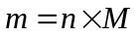
m = mass (in grams)
n = moles
M = Molar Mass

Example:
- How many moles of silicon are in a 56.18-g sample?

- What is the mass of 10.0 mol of water?

- How many moles are in 360 g of glucose, C₆H₁₂O_{6(s)}?

- What is the mass of 5.00 mol of NH_{3(g)}?

